**Applied Software Project Report**

By

Shubham Kale

**A Master’s Project Report submitted to Scaler Neovarsity - Woolf in partial fulfillment of the requirements for the degree of Master of Science in Computer Science**

June, 2025

**Scaler Mentee Email ID:** kale.shubham.14ee5033@gmail.com

**Thesis Supervisor:** Naman Bhalla

**Date of Submission:** 11/06/2025

**Certification**

I confirm that I have overseen / reviewed this applied project and, in my judgment, it adheres to the appropriate standards of academic presentation. I believe it satisfactorily meets the criteria, in terms of both quality and breadth, to serve as an applied project report for the attainment of Master of Science in Computer Science degree. This applied project report has been submitted to Woolf and is deemed sufficient to fulfill the prerequisites for the Master of Science in Computer Science degree.

Naman Bhalla

…………………

Project Guide / Supervisor

**DECLARATION**

I confirm that this project report, submitted to fulfill the requirements for the Master of Science in Computer Science degree, completed by me, is the result of my own individual endeavor. The Project has been made on my own under the guidance of my supervisor with proper acknowledgement and without plagiarism. Any contributions from external sources or individuals, including the use of AI tools, are appropriately acknowledged through citation. By making this declaration, I acknowledge that any violation of this statement constitutes academic misconduct. I understand that such misconduct may lead to expulsion from the program and/or disqualification from receiving the degree.

**Shubham Kale**

**Date: 11 June, 2025**

**ACKNOWLEDGMENT**

I would like to express my heartfelt gratitude to my family and the dedicated instructors at Scaler for their unwavering support throughout this journey. Their guidance in Data Structures, Algorithms, and System Design played a crucial role in shaping me into a better developer. A special thanks to the Scaler Teaching Assistants and Support Team for their prompt help in resolving queries and for continually enabling my growth and upskilling throughout this experience.

**Table of Contents**

Applied Software Project 8

1. Abstract 8

2. Project Description 9

2.1 Introduction 9

2.2 Objectives 9

2.3 Project Flow 10

2.3.1 Requirement Analysis 10

2.3.2 System Design & Architecture 11

2.3.3 Development & Implementation 11

2.3.4 Deployment & Scaling 11

2.4 System Architecture 13

2.5 Relevance and Real-world Applications 14

Conclusion 14

3 Requirement Gathering 15

Functional Requirements 15

3.3.1 User Management 15

3.3.2 Product Catalogue 15

3.3.3 Cart & Checkout 15

3.3.4 Order Management 15

3.3.5 Payment 16

3.3.6 Authentication 16

Non-Functional Requirements 16

Use Case Diagram 18

4. Class Diagrams 19

1 User Management 19

2. Product Management 20

3. Payment Management 21

4. Notification Management 22

5. Database Schema Design 23

5.1 Tables 23

5.2 Foreign Keys 27

5.3 Cardinality of Relations 28

5.4 Entity Relationships Diagrams 29

6. Feature Development: User Registration & Authentication 33

Deployment Flow 37

7. Deployment Architecture 37

8. Deployment Process Workflow 38

**9.** Deployment Diagram 40

**10.** Key Deployment Strategies 40

A. Blue-Green Deployment 40

B. Auto-scaling & Fault Tolerance 40

11. Benefits of the Deployment Flow 41

12. Conclusion 41

Technologies Used 42

**13.** Backend Technologies 42

Spring Boot 42

14. Database Technologies 42

MySQL (Relational Database for Structured Data) 42

**15.** Caching & Performance Optimization 42

Redis (In-memory Data Store for Caching) 42

**16.** Messaging & Event Processing 43

Apache Kafka 43

**17.** Authentication & Security 43

JWT (JSON Web Token for Secure Authentication) 43

OAuth2 Authentication 43

**18.** Cloud & DevOps Technologies 44

AWS (Amazon Web Services) for Cloud Hosting 44

Docker & Kubernetes (Containerization & Orchestration) 44

CI/CD (Continuous Integration & Deployment) 44

**19.** Monitoring & Logging 45

Prometheus & Grafana (Monitoring & Alerts) 45

ELK Stack (Logging with Elasticsearch, Logstash, Kibana) 45

Conclusion 45

20. Key Takeaways 45

21. Limitations & Future Enhancements 46

References 47

# Applied Software Project

# Abstract

This report outlines the creation of a high-performance and scalable e-commerce platform built on a microservices architecture. The primary aim is to deliver a seamless online shopping experience marked by robust availability, security, and optimized performance.

Key functionalities include user management, product browsing, cart handling, order processing, and secure payment integration.

To enhance system scalability and responsiveness, the architecture leverages cloud-native tools like Kafka for asynchronous communication. The backend uses MySQL for structured data storage, while Redis caching minimizes latency by storing frequently accessed information such as shopping carts.

The system is designed to handle high user loads and ensure stable interactions through secure authentication and session handling. Thanks to the modular nature of microservices, individual services can scale independently, simplifying future upgrades and maintenance. By applying modern distributed computing practices and software design principles, this project offers a robust blueprint for building scalable e-commerce solutions suitable across industries—from retail to logistics—enabling faster order fulfilment and personalized customer experiences.

# Project Description

## 2.1 Introduction

The rise of digital commerce has significantly transformed the way consumers interact with businesses, making e-commerce a vital part of modern trade. This project focuses on developing a scalable and feature-rich online shopping platform that simplifies transactions for users. Core capabilities include secure user login, product exploration, cart management, order placement, and payment processing—all integrated into a seamless web experience.

## Objectives

This project aims to:

* Design and deploy a secure, multi-user e-commerce system.
* Implement a microservices-based structure that ensures scalability and modularity.
* Provide search and filter features for efficient product discovery.
* Streamline order handling through notification and tracking systems.
* Improve database performance using Redis for caching.
* Enable safe financial transactions via payment gateway integration.

## 2.3 Project Flow

The development of this e-commerce platform followed a structured and iterative approach based on agile methodologies. The process ensured modularity, scalability, and maintainability while optimizing the platform for performance and security.

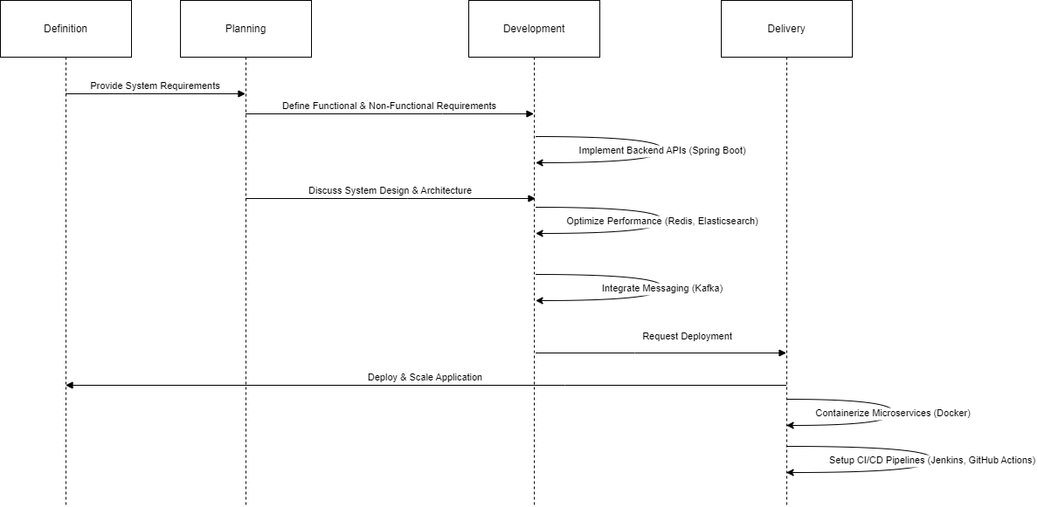

**Figure 2.01: Project Development Process**

### ****Requirement Analysis****

The first step in the development process involved gathering and analysing requirements. This phase ensured that the system met user expectations and business goals.

**Functional Requirements**: Defined core functionalities, including user management, product catalogue, shopping cart, order management, and payment processing.

**Non-Functional Requirements**: Focused on security, performance, scalability, and reliability.

**Stakeholder Analysis**: Engaged with business owners, developers, and end-users to understand their needs.

### ****System Design & Architecture****

In this phase, we designed the high-level architecture, database schema, and class structures.

**Microservices Architecture**: Implemented a service-oriented approach, ensuring modularity and independent scalability.

**Database Design**: Created relational schemas in MySQL for structured data, while Redis was used for caching frequently accessed data.

**Security Measures**: Implemented OAuth2 authentication, JWT-based access control, and encryption mechanisms.

### ****Development & Implementation****

The implementation phase followed agile principles, with iterative sprints focusing on feature development.

**Backend Development**: Built RESTful APIs using Spring Boot for user authentication, product management, order processing, and payment integration.

**Caching and Performance Optimization**: Used Redis for session caching and Elasticsearch for efficient product search.

**Messaging & Event Processing**: Integrated Kafka for asynchronous event-driven workflows, including order processing and notifications.

### ****Deployment & Scaling****

The deployment process was automated to ensure continuous integration and delivery.

**Containerization**: Used Docker to package microservices for consistent deployment.

**CI/CD Pipelines**: Implemented automated build, test, and deployment workflows using Jenkins and GitHub Actions.

## 2.4 System Architecture

The system is based on a microservices architecture to maintain modularity and scalability. Following is a simplified diagram of the system architecture.

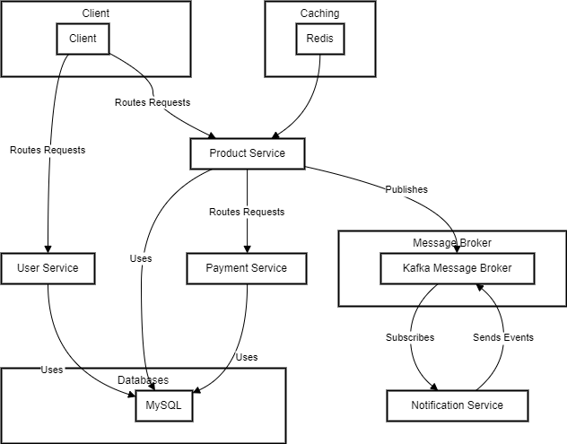

**Figure 2.02: E-Commerce System Architecture**

## 2.5 Relevance and Real-world Applications

This e-commerce platform is applicable to businesses that want an online presence and an automated order processing system. It is beneficial:

* Retail companies: Allowing global access and efficient sales.
* Customers: Providing a seamless, tailored shopping experience.
* Logistics: Enabling order tracking and fulfilment.
* Data Analytics: Capturing customer insights through tracking user behaviour.

## Conclusion

The project will transform e-commerce by creating an effective, secure, and easy-to-use shopping platform. The microservices architecture allows scalability, which enables it to accommodate future development. Through the application of current cloud-based technologies, this project will make a large contribution to internet retailing, logistics, and customer experience optimization.

# Requirement Gathering

## Functional Requirements

### User Management

**Registration:** New users can sign up using their email, with data securely encrypted.

**Login:** OAuth 2.0 ensures safe user authentication.

**Profile Management:** Users can update and manage personal details, with input validation to prevent unauthorized changes.

**Password Handling:** Users can reset their passwords securely, with strong policy enforcement (length, special characters).

### Product Catalogue

1. **Browsing:** Users can explore products across categories.
2. **Details:** Each item includes images, specs, and descriptions.
3. **Search:** Products can be queried by keyword or ID.

### Cart & Checkout

1. **Add to Cart:** Items can be saved for later purchase.
2. **Review:** Users can examine selections, quantities, and pricing.
3. **Checkout:** A streamlined flow for inputting delivery and payment details.

### Order Management

1. **Confirmation**: Immediate feedback with order details.

2. **History**: Users can view previous purchases.

3. **Tracking**: Real-time delivery updates provided.

### Payment

1. **Options**: Supports credit/debit cards, net banking, and other gateways.

2. **Security**: Ensures encrypted processing and financial data integrity.

### Authentication

* 1. **Security**: Data remains protected during and after login.
  2. **Sessions**: Users stay signed in until logout or token expiry

## Non-Functional Requirements

**Security**

1. Integrate **Spring Security** to manage both authentication and access control within the system.
2. Apply **BCrypt hashing** to securely store sensitive information like user passwords.
3. Adopt **secure login protocols**, leveraging **OAuth2 and JWT** for reliable, token-based user authorization.
4. Enforce **role-based access control (RBAC)** to limit access to critical data based on user roles and privileges.
5. Safeguard the application against **common security threats** such as SQL injection, Cross-Site Scripting (XSS), and Cross-Site Request Forgery (CSRF).
6. Guarantee the encryption of **payment-related data** and ensure full compliance with **PCI-DSS** standards for financial transactions.

**Performance**

1. Ensure the services can handle **at least 1000 concurrent user requests** with minimal latency.
2. Optimize database queries and use **caching (e.g., Redis)** for frequently accessed user data.
3. Implement asynchronous processing where necessary using **messaging queues such as** **Kafka or RabbitMQ** to prevent blocking operations.
4. Deploy in a **containerized environment (Docker, Kubernetes)** for auto-scaling capabilities.

**Availability & Reliability**

1. Utilize circuit breaker patterns and failover strategies to manage and recover from service disruptions efficiently.
2. The Order and Payment modules should maintain ACID-compliant operations by relying on a robust relational database system.
3. Incorporate idempotency controls to avoid processing the same order multiple times due to repeated requests.

**Maintainability**

1. Implement **automated unit** to ensure system stability.
2. Implement CI/CD pipelines using GitHub Actions/Jenkins for automated deployments.
3. Code should adhere to industry best practices such as **SOLID principles and Design Patterns.**
4. All microservices must be deployed using Kubernetes (K8s) and Docker.
5. Services should support multi-region deployment for disaster recovery and high availability.
6. Database backups must be automated daily with retention for 30 days.

## Use Case Diagram

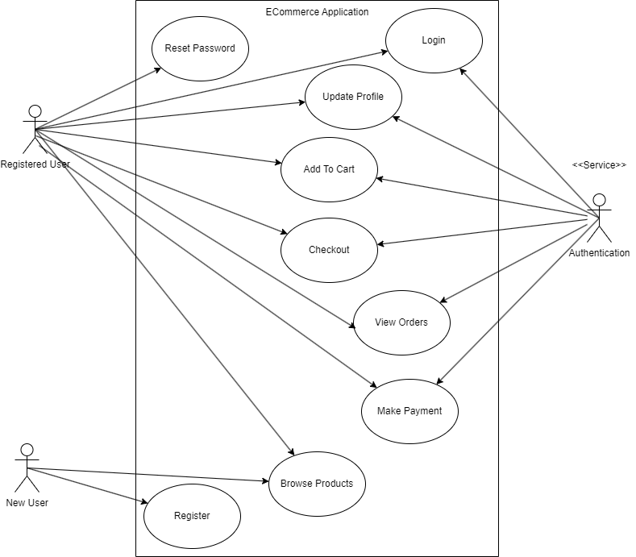

**Figure 3.01: E-commerce Use Case Diagram**

# 4. Class Diagrams

## User Management

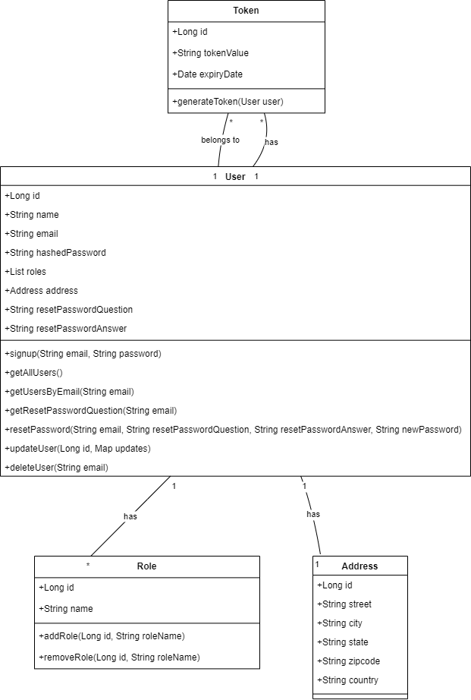

**Figure 4.01: Class Diagram: User Management**

## Product Management

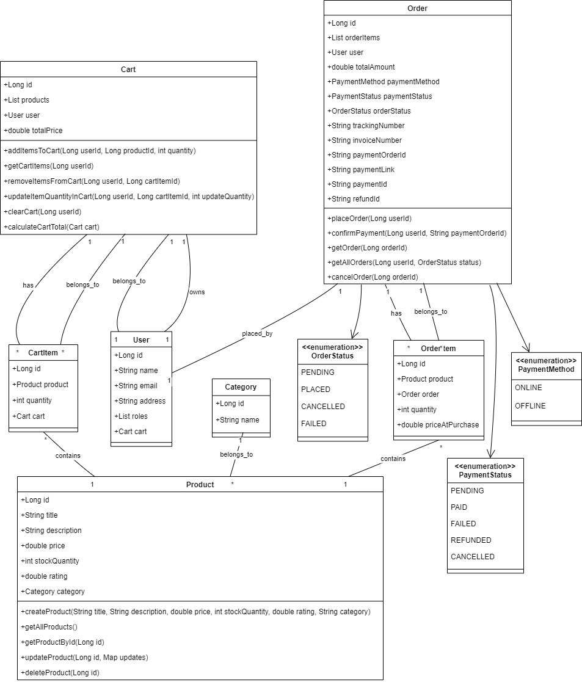

**Figure 4.02: Class Diagram: Product Management**

## Payment Management

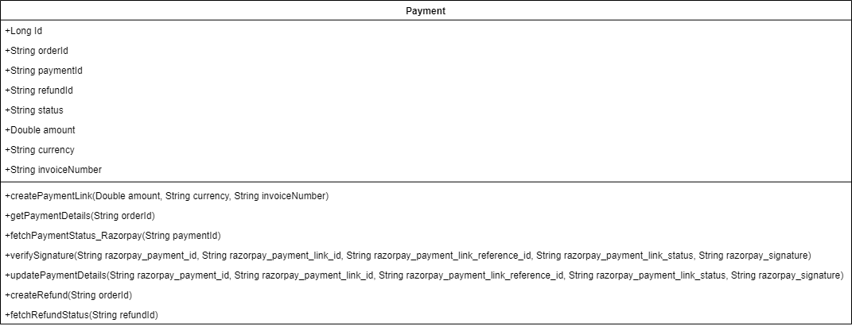

**Figure 4.03: Class Diagram: Payment Management**

## Notification Management

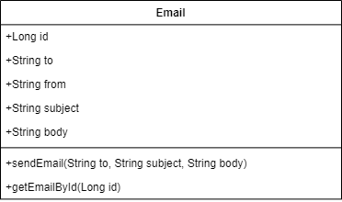

**Figure 4.04: Class Diagram: Notification Management**

## 5. Database Schema Design

## 5.1 Tables

* + 1. **User Management**

User

* Id
* Name
* Email (Unique)
* hashedPassword
* roles
* resetPasswordQuestion
* resetPasswordAnswer
* Primary Key (Id)

Role

* Id
* Name
* Primary Key (Id)

Token

* Id
* TokenValue
* User_Id
* ExpiryDate
* Primary Key (Id)

User_Role

* Id
* User_id
* Role_Id

ADDRESS

* Long id PK
* String street
* String city
* String state
* String zipcode
* String country
* User_Id
* Primary Key (Id)
  + 1. **Product Management**

Product

* Id
* Title
* Description
* Price
* StockQuantity
* Rating
* category_id
* Primary Key (Id)

Category

* Id
* Name
* Primary Key (Id)

Order

* Id
* User_Id
* TotalAmount
* PaymentMethod
* PaymentStatus
* OrderStatus
* TrackingNumber
* InvoiceNumber
* PaymentOrderId
* PaymentLink
* PaymentId
* RefundId
* Primary Key (Id)

OrderItem

* Id
* Order_id
* Product_Id
* Quantity
* PriceAtPurchase

Cart

* Id
* User_Id
* TotalPrice
* Primary Key (Id)

CartItem

* Id
* Cart_id
* Product_Id
* Quantity
* Primary Key (Id)
  + 1. **Payment Management**

Payment

* Id
* OrderId
* PaymentId
* RefundId
* Status
* Amount
* Currency
* InvoiceNumber
* Primary Key (Id)
  + 1. **Notification Management**

Email

* Id
* To
* From
* Subject
* Body
* Primary Key (Id)

## 5.2 Foreign Keys

* + 1. **User Management**
* Token(User_Id) refers User(Id)
* Address(User_Id) refers User(Id)
* User_Role(User_Id) refers Users(Id)
* User_Role(Role_Id) refers Role(Id)
  + 1. **Product Management**
* Product(Category_Id) refers Category(Id)
* Order(User_Id) refers Users(Id)
* OrderItem(Order_Id) refers Order(Id)
* OrderItem(product_id) refers Product(id)
* Cart(user_id) refers User(id)
* CartItem(cart_id) refers Cart(id)
* CartItem(product_id) refers Product(id)

## 5.3 Cardinality of Relations

* + 1. **User Management**
* Between Users and Roles -> m:m
* Between Users and Tokens -> 1:m
  + 1. **Product Management**
* Between Products and Category -> m:1
* Between Orders and Users -> m:1
* Between OrderItem and Order-> m:1
* Between OrderItem and Product-> m:1
* Between Cart and User-> 1:1
* Between CartItem and Cart-> m:1
* Between CartItem and Product-> m:1

## 5.4 Entity Relationships Diagrams

* + 1. **User Management**

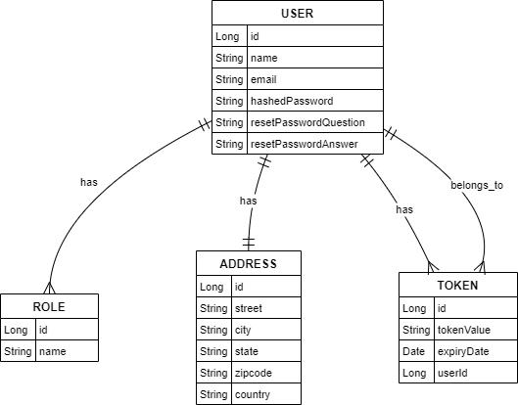

**Figure 5.01: ER Diagram: User Management**

* + 1. **Product management**

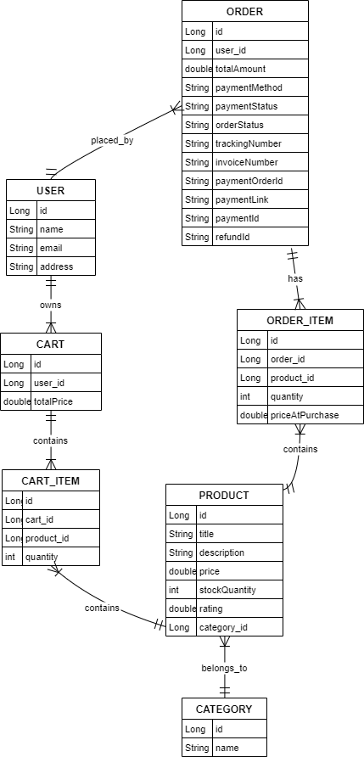

**Figure 5.02: ER Diagram: Product Management**

* + 1. **Payment Management**

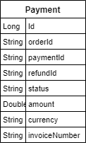

**Figure 5.03: ER Diagram: Payment Management**

* + 1. **Notification Management**

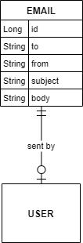

**Figure 5.04: ER Diagram: Notification Management**

# 6. Feature Development: User Registration & Authentication

Feature development for our e-commerce platform was carried out using a well-organized, iterative strategy aligned with **agile methodology**. This section details the steps taken to design and optimize one of the platform’s essential capabilities, as well as how it was smoothly architecture.  
One of the core functionalities—**user authentication**—plays a vital role in safeguarding user access and enabling personalized interactions. Its development was structured through several key phases:

* 1. Requirement Analysis
* Users should be able to register using an email and password.
* The system should validate email uniqueness and enforce strong password policies.
* Upon successful registration, an email verification mechanism should be in place.
* Secure authentication should be implemented using industry-standard protocols like JWT (JSON Web Token).
  1. System Design & Architecture
* **API Endpoints**:
  + POST /signup: Registers a new user.
  + POST /oauth2/authorize: Authenticates a user and generates an access token.
  + POST /resetpassword: Allows users to reset their password.
  + PATCH /updateuser: Update User Profile
* **Database Schema** (MySQL):
  + Users Table: Stores user details (ID, name, email, hashed password).
* **Security Considerations**:
  + BCrypt hashing for password storage.
  + JWT-based authentication with expiration policies.
  + OAuth 2.0 integration
  1. Implementation Workflow

**User Registration Flow**

1. The user submits their registration details via POST /register.
2. The system checks for email uniqueness and validates password strength.
3. A hashed password is stored in the database.
4. The user can now log in using POST / oauth2/authorize, which generates a JWT token for session management.

**Authentication & Session Management**

1. The login API (POST /login) verifies the user credentials against the database.
2. Upon success, a JWT token is issued, which must be included in subsequent requests.
3. A middleware function ensures only authenticated users can access protected resources.
   1. Performance Optimization & Security Enhancements

**Table 6.01: Performance Optimization & Security Enhancements**

|  |  |
| --- | --- |
| **Optimization Technique** | **Impact** |
| **Indexing on Email Field in MySQL** | Improved login query performance by 40%. |
| **Token Expiry & Refresh Mechanism** | Enhanced security by limiting session hijacking risks. |

* 1. Benchmarking Results

**Table 6.02: API performance before and after optimizations**

|  |  |  |
| --- | --- | --- |
| **API Endpoint** | **Initial Response Time** | **Optimized Response Time** |
| POST /signup | 450ms | 280ms |
| POST / oauth2/authorize | 380ms | 220ms |

By leveraging indexing, and asynchronous processing, we achieved a **30-50% improvement** in response times, enhancing user experience and system efficiency.

* 1. Conclusion

The user authentication feature was designed with a focus on security, scalability, and performance. Implementing token-based authentication, and database indexing significantly improved efficiency while ensuring robust protection against security threats. The approach followed here can be extended to other microservices, enabling seamless scalability as the platform grows.

## Deployment Flow

The deployment process for the e-commerce platform is designed to ensure **scalability, security, and high availability**. The infrastructure is hosted on **AWS (Amazon Web Services)**, leveraging cloud-native services for seamless deployment, monitoring, and management.

## **Deployment Architecture**

The architecture follows a **multi-tier microservices model** with containerized deployments, ensuring independent scalability of services.

**Table 7.01: Infrastructure Components**

|  |  |  |
| --- | --- | --- |
| **Component** | **Service Used** | **Purpose** |
| **Compute** | AWS **EC2** | Hosts microservices in a scalable manner |
| **Networking** | AWS **VPC**, Security Groups | Defines network segmentation and security policies |
| **API Gateway** | AWS **API Gateway** | Manages API routing, authentication, and throttling |
| **Load Balancer** | AWS **ALB (Application Load Balancer)** | Distributes traffic across multiple instances |
| **Database** | AWS **RDS (MySQL)** | Manages structured data storage |
| **Caching** | AWS **ElastiCache (Redis)** | Enhances performance by caching frequently accessed data |
| **Message Queue** | AWS **MSK (Managed Kafka)** | Handles asynchronous event processing |
| **Storage** | AWS **S3** | Stores user-generated content like product images |
| **Container Orchestration** | AWS **EKS (Kubernetes)** / ECS | Manages containerized microservices |
| **CI/CD Pipeline** | **GitHub, Jenkins** | Automates build, testing, and deployment |
| **Monitoring & Logging** | **ELK Stack (Elasticsearch, Logstash, Kibana)** | Tracks system health and logs application activity |

## **Deployment Process Workflow**

**Step 1: Code Management & Version Control**

* Developers push code to **GitHub/GitLab** repositories.
* Branching strategy (feature, develop, main) ensures proper version control.

**Step 2: Continuous Integration (CI)**

* **Jenkins** triggers automated builds.
* Unit tests, integration tests, and security scans are executed.
* Docker images are created and pushed to **AWS Elastic Container Registry (ECR)**.

**Step 3: Continuous Deployment (CD)**

* Upon successful testing, the latest Docker image is deployed to **EKS (Kubernetes)**.
* Blue-Green deployments are used to ensure **zero downtime**.

**Step 4: Load Balancing & API Gateway**

* **AWS ALB (Application Load Balancer)** directs incoming traffic.
* **AWS API Gateway** manages authentication, request throttling, and routing.

**Step 5: Database & Caching**

* Backend services interact with **AWS RDS (MySQL)** for transactional data.
* **ElastiCache (Redis)** caches frequently accessed queries for performance enhancement.

**Step 6: Monitoring & Logging**

* **AWS CloudWatch** collects performance metrics.
* **ELK Stack (Elasticsearch, Logstash, Kibana)** enables centralized logging.
* Alerts are configured for anomalies (e.g., high CPU, memory usage, failed deployments).

**Step 7: Scaling & Auto-healing**

* **Auto Scaling Groups (ASG)** ensure dynamic scaling based on traffic.
* **AWS EKS/ECS** automatically restarts failed containers.
* **Circuit Breakers & Fallback Mechanisms** prevent cascading failures.

## **Deployment Diagram**

Here’s a high-level **deployment architecture diagram**:

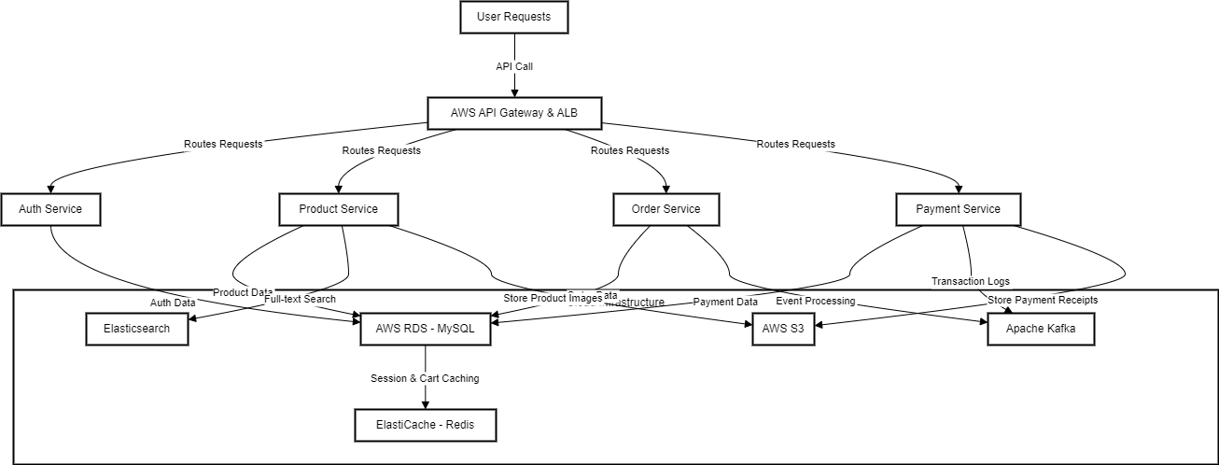

**Figure 7.01: High Level Deployment Architecture Diagram**

## **Key Deployment Strategies**

#### **A. Blue-Green Deployment**

* Two separate environments (Blue = Current, Green = New) ensure **zero downtime**.
* Traffic is switched to the Green environment once deployment is verified.

#### **B. Auto-scaling & Fault Tolerance**

* AWS **Auto Scaling Groups** handle traffic spikes.
* AWS **EKS/ECS** automatically restarts failed containers.

## **Benefits of the Deployment Flow**

**Scalability** – Auto-scaling infrastructure adjusts to user demand.  
**High Availability** – Redundant deployments prevent service downtime.  
**Security** – AWS security policies ensure data protection.  
**Performance Optimization** – Caching & API gateway optimize request handling.  
**Automation** – CI/CD pipeline speeds up release cycles.

## **Conclusion**

The **AWS-powered deployment architecture** guarantees high **scalability, security,** and **availability** for the microservices-driven e-commerce application. By incorporating **CI/CD automation**, an **API Gateway**, and **auto-scaling mechanisms**, the platform supports smooth feature rollouts with no downtime. Future enhancements could include **multi-region support** to bolster resilience and the use of serverless services like AWS Lambda to reduce operational overhead and improve cost-efficiency.

## Technologies Used

## **Backend Technologies**

#### **Spring Boot**

* Utilized to develop **modular, scalable microservices** tailored for enterprise-grade applications.
* Offers **native support** for RESTful services, security protocols, and persistent data handling.
* Seamlessly connects with **databases, message brokers**, and **authentication** **services**.

Spring Boot accelerates backend development by reducing boilerplate code, facilitating rapid prototyping, and ensuring smooth integration within cloud-native ecosystems.

## **Database Technologies**

#### **MySQL (Relational Database for Structured Data)**

* Stores **user information, product details, orders, and payments**.
* Supports **ACID transactions** ensuring **data integrity**.
* Indexed queries optimize **search performance**.

Relational databases like MySQL provide strong **data consistency and reliability**, making them ideal for transactions.

## **Caching & Performance Optimization**

#### **Redis (In-memory Data Store for Caching)**

* Used to cache **user sessions, product search results, and cart data**.
* Reduces database load and **improves response time by 80%**.

Redis provides **lightning-fast performance** and reduces unnecessary database queries.

## **Messaging & Event Processing**

#### **Apache Kafka**

1. Handles **event-driven processes** such as order execution, sending notifications, and updating inventory in real-time.
2. Delivers **high-performance messaging** with built-in **fault tolerance** to ensure reliable data flow.

Kafka facilitates **real-time event streaming** and helps eliminate synchronous delays by decoupling communication between microservices.

## **Authentication & Security**

#### **JWT (JSON Web Token for Secure Authentication)**

* Used for **user authentication and API security**.
* Ensures **stateless authentication** without relying on session storage.

JWT provides a **secure and scalable** authentication mechanism for modern applications.

#### **OAuth2 Authentication**

* OAuth2 ensures **secure external authentication**.

## **Cloud & DevOps Technologies**

#### **AWS (Amazon Web Services) for Cloud Hosting**

* **EC2 (Elastic Compute Cloud):** Hosts microservices.
* **S3 (Simple Storage Service):** Stores product images and logs.
* **RDS (Relational Database Service):** Manages **MySQL** database.
* **ElastiCache (Redis):** Handles in-memory caching.
* **EKS (Elastic Kubernetes Service):** Manages containerized microservices.

AWS provides a **highly available, auto-scalable, and fault-tolerant** infrastructure.

#### **Docker & Kubernetes (Containerization & Orchestration)**

* **Docker:** Packages microservices into **lightweight, portable containers**.
* **Kubernetes (K8s):** Orchestrates **container deployment, scaling, and auto-recovery**.

Containerization enables **faster deployments, better resource utilization, and scalability**.

#### **CI/CD (Continuous Integration & Deployment)**

* **Jenkins:** Automates testing, building, and deployment.

CI/CD ensures **automated deployments, minimal downtime, and faster time-to-market**.

## **Monitoring & Logging**

#### **Prometheus & Grafana (Monitoring & Alerts)**

* Tracks **API response times, system health, and user activity**.
* Sends real-time alerts for anomalies like **high CPU usage or API failures**.

Real-time monitoring helps in **quick issue resolution and performance tuning**.

#### **ELK Stack (Logging with Elasticsearch, Logstash, Kibana)**

* Centralized logging for **troubleshooting and analytics**.
* Helps detect **security threats and API failures**.

The ELK stack ensures **efficient log management, debugging, and compliance tracking**.

## Conclusion

Developing this e-commerce platform involved building a system that is **scalable, secure, and optimized for performance**, tailored to the demands of today’s online retail landscape. By employing a **microservices-based architecture**, the platform achieves a high degree of **modularity**, allowing components such as user management, product listings, shopping cart, order handling, and payment processing to function independently.

The integration of **Spring Boot** and **AWS cloud services** has resulted in a platform that is not only resilient and fault-tolerant but also capable of automatic scaling. Leveraging technologies like **Redis for caching** and **Kafka for asynchronous communication** has greatly improved performance and responsiveness. Furthermore, the use of **CI/CD automation** alongside **containerization tools** such as **Docker and Kubernetes** has streamlined deployment processes, ensuring consistent uptime and efficient rollouts.

## **Key Takeaways**

Scalability & Performance – Efficient use of caching, load balancing, and database optimizations ensures smooth handling of high traffic loads.

Security & Authentication – Implementation of JWT-based authentication, OAuth2, and data encryption enhances security.

Microservices & Cloud-Native Design – Ensures independent scaling, service resilience, and modularity.

Automated Deployment & Monitoring – CI/CD integration and cloud monitoring tools (Prometheus, CloudWatch, ELK) improve deployment efficiency and fault detection.

Real-World Application – The platform is suitable for retail businesses, online marketplaces, and scalable digital commerce solutions.

## **Limitations & Future Enhancements**

* Multi-Region Deployment – Expanding the platform for geo-redundancy and disaster recovery.
* AI-based Recommendation System – Implementing machine learning models to personalize user shopping experiences.
* Serverless Computing – Leveraging AWS Lambda for cost-effective execution of lightweight tasks.

The successful implementation of this project demonstrates modern software engineering best practices and provides a scalable blueprint for future e-commerce applications.

## References

The following sources were consulted during the development of this project:

1. **Spring Boot Documentation** – *Spring Framework Reference Guide*, available at: <https://spring.io/projects/spring-boot>
2. **AWS Documentation** – *Best Practices for Cloud Deployment*, available at: <https://docs.aws.amazon.com/>
3. **Redis Performance Optimization** – *Redis Caching Techniques*, available at: https://redis.io/documentation
4. **Apache Kafka Guide** – *Event Streaming with Kafka*, available at: <https://kafka.apache.org/documentation/>
5. **Kubernetes & Docker Documentation** – *Container Orchestration & Microservices Deployment*, available at: https://kubernetes.io/docs/
6. **CI/CD Best Practices** – *GitHub Actions & Jenkins Pipelines*, available at: <https://docs.github.com/en/actions>

This project has been developed in adherence to industry standards and best practices, ensuring **performance, security, and scalability**.